UNIT I
SINGLE STAGE AMPLIFIERS
1.1 Introduction
V-I characteristics of an active device such as BJT are non-linear. The analysis of a non- linear device is complex. Thus to simplify the analysis of the BJT, its operation is restricted to the linear V-I characteristics around the Q-point i.e. in the active region. This approximation is possible only with small input signals. With small input signals transistor can be replaced with small signal linear model. This model is also called small signal equivalent circuit.
1.2Two –Port Devices and Network Parameters
Small signal low frequency transistor Models:
All the transistor amplifiers are two port networks having two voltages and two currents. The positive directions of voltages and currents are shown in fig. 1.
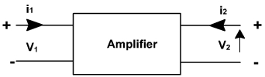
Fig. 1
A two-port network is represented by four external variables: voltage V₁ and current I₁ at the input port, and voltage V₂ and current I₂ at the output port, so that the two-port network can be treated as a black box modeled by the relationships between the four variables,V₁,V₂, I₁,I₂ . Out of four variables two can be selected as are independent variables and two are dependent variables.The dependent variables can be expressed interns of independent variables. This leads to various two port parameters out of which the following three are important:
- Impedance parameters (z-parameters)
- Admittance parameters (y-parameters)
- Hybrid parameters (h-parameters)

1.1.1 z-parameters

A two-port network can be described by z-parameters as

In matrix form, the above equation can be rewritten as
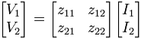
Where
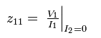
Input impedance with output port open circuited
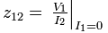
Reverse transfer impedance with input port open circuited
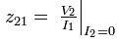
Forward transfer impedance with output port open circuited
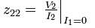
Output impedance with input port open circuited
1.1.2 Y-parameters

A two-port network can be described by Y-parameters as

In matrix form, the above equation can be rewritten as
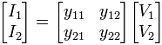
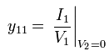
Input admittance with output port short circuited
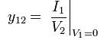
Reverse transfer admittance with input port short circuited
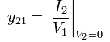
Forward transfer admittance with output port short circuited
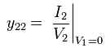
Output admittance with input port short circuited
1.1.3 Hybrid parameters (h-parameters)
If the input current I1 and output voltage V2 are taken as independent variables, the dependent variables V1 and I2 can be written as
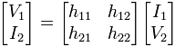
Where h₁₁, h₁₂, h₂₁, h₂₂ are called as hybrid parameters.
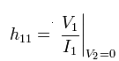
Input impedence with o/p port short circuited
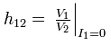
Reverse voltage transfer ratio with i/p port open circuited
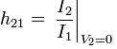
Forward voltage transfer ratio with o/p port short circuited

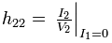
output impedence with i/p port open circuited
1.2 THE HYBRID MODEL FOR TWO PORT NETWORK:
Based on the definition of hybrid parameters the mathematical model for two pert networks known as h-parameter model can be developed. The hybrid equations can be written as:
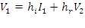
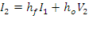
(The following convenient alternative subscript notation is recommended
by the IEEE Standards:
i=11= input o = 22 = output
f =21 = forward transfer r = 12 = reverse transfer)
We may now use the four h parameters to construct a mathematical model of the device of Fig.(1). The hybrid circuit for any device indicated in Fig.(2). We can verify that the model of Fig.(2) satisfies above equations by writing Kirchhoff'svoltage and current laws for input and output ports.
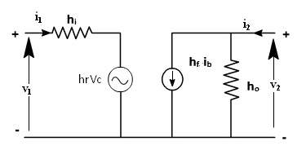
If these parameters are specified for a particular configuration, then suffixes e,b or c are also included, e.g. h_{fe} ,h _{ib} are h parameters of common emitter and common collector amplifiers
Using two equations the generalized model of the amplifier can be drawn as shown in fig. 2.
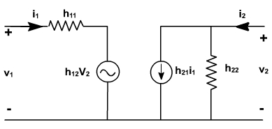
Fig. 2
1.2.1 TRANSISTOR HYBRID MODEL:
The hybrid model for a transistor amplifier can be derived as follow:
Let us consider CE configuration as show in fig. 3. The variables, i_{B}, i_{C} ,v_{C}, and v_{B} represent total instantaneous currents and voltages i_{B} and v_{C} can be taken as independent variables and v_{B}, I_{C} as dependent variables.
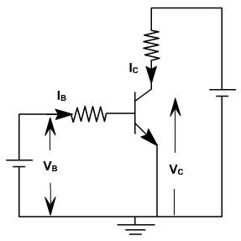
Fig. 3
V_{B} = f1 (i_{B} ,v_{C} )
I_{C} = f2 (i_{B} ,v_{C}).
Using Taylor 's series expression, and neglecting higher order terms we obtain.
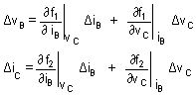
The partial derivatives are taken keeping the collector voltage or base current constant. The Δ v_{B}, Δ v_{C}, Δ i_{B}, Δ i_{C} represent the small signal (incremental) base and collector current and voltage and can be represented as v_{B}, i_{C,} i_{B} ,v_{C}
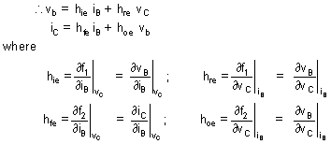
The model for CE configuration is shown in fig. 4.
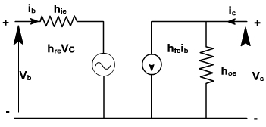
Fig. 4
To determine the four h-parameters of transistor amplifier, input and output characteristic are used. Input characteristic depicts the relationship between input voltage and input current with output voltage as parameter. The output characteristic depicts the relationship between output voltage and output current with input current as parameter. Fig. 5, shows the output characteristics of CE amplifier.
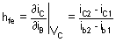
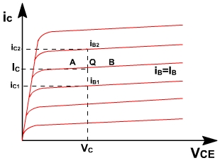
Fig. 5
The current increments are taken around the quiescent point Q which corresponds to i_{B} = I_{B} and to the collector voltage V_{CE} = V_{C}
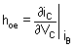
The value of h_{oe} at the quiescent operating point is given by the slope of the output characteristic at the operating point (i.e. slope of tangent AB).
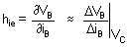
h_{ie} is the slope of the appropriate input on fig. 6, at the operating point (slope of tangent EF at Q).
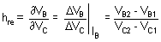
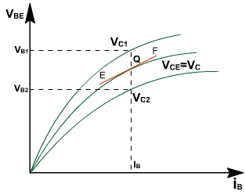
Fig. 6
A vertical line on the input characteristic represents constant base current. The parameter hre can be obtained from the ratio (V_{B2}– V _{B1} ) and (V_{C2}– V _{C1} ) for at Q.
Typical CE h-parametersof transistor 2N1573 are given below:
h_{ie} = 1000 ohm.
h_{re} = 2.5 * 10 –4
h_{fe} = 50
h_{oe} = 25  A / V

1.3 ANALYSIS OF A TRANSISTOR AMPLIFIER USING H-PARAMETERS:
To form a transistor amplifier it is only necessary to connect an external load and signal source as indicated in fig. 1 and to bias the transistor properly.
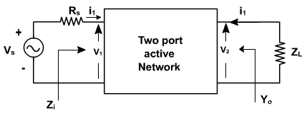
Fig. 1
Consider the two-port network of CE amplifier. R_{S} is the source resistance and Z_{L} is the load impedence h-parameters are assumed to be constant over the operating range. The ac equivalent circuit is shown in fig. 2. (Phasor notations are used assuming sinusoidal voltage input). The quantities of interest are the current gain, input impedence, voltage gain, and output impedence.
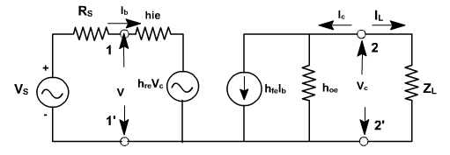
Fig. 2
1.3.1 Current gain:
For the transistor amplifier stage, A_{i} is defined as the ratio of output to input currents.
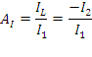
1.3.2 Input impedence:
The impedence looking into the amplifier input terminals ( 1,1' ) is the input impedence Z_{i} 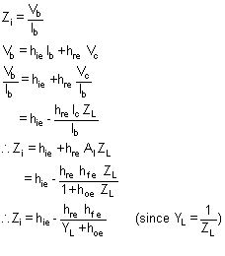
1.3.3 Voltage gain:
The ratio of output voltage to input voltage gives the gain of the transistors.
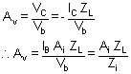
1.3.4 Output Admittance:
It is defined as
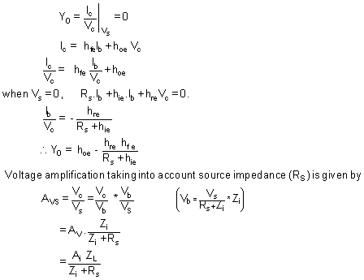
A_{v} is the voltage gain for an ideal voltage source (R_{v} = 0).
Consider input source to be a current source I_{S} in parallel with a resistance R_{S} as shown in fig. 3.
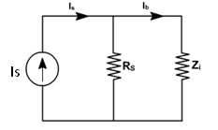 Fig. 3
In this case, overall current gain A_{IS} is defined as
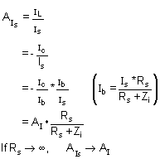

h-parameters
To analyze multistage amplifier the h-parameters of the transistor used are obtained from manufacture data sheet. The manufacture data sheet usually provides h-parameter in CE configuration. These parameters may be converted into CC and CB values. For example fig. 4 hrc in terms of CE parameter can be obtained as follows.
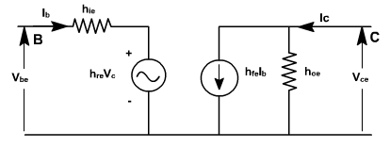
Fig. 4
For CE transistor configuaration
Vbe = hie Ib + hre Vce
Ic = h fe Ib + hoe Vce
The circuit can be redrawn like CC transistor configuration as shown in fig. 5.
Vbc = hie Ib + hrc Vec
Ic = hfe Ib + hoe Vec

hybrid model for transistor in three different configurations
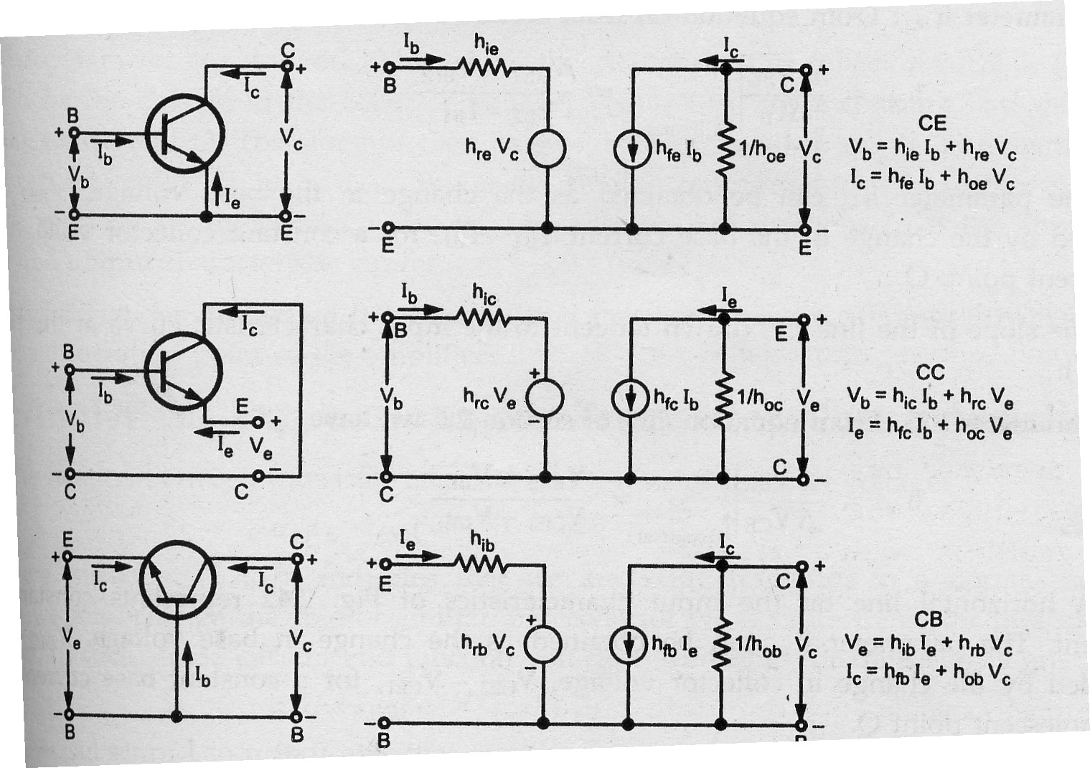

Typical h-parameter values for a transistor
Parameter | CE | CC | CB
h_{i} | 1100 Ω | 1100 Ω | 22 Ω
h_{r} | 2.5 × 10⁻⁴ | 1 | 3 × 10⁻⁴
h_{f} | 50 | -51 | -0.98
h_{o} | 25 µA/V | 25 µA/V | 0.49 µA/V

Analysis of a Transistor amplifier circuit using h-parameters
A transistor amplifier can be constructed by connecting an external load and signal source and biasing the transistor properly.

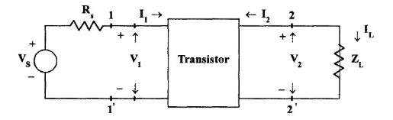
Fig.1.4 Basic Amplifier Circuit

The two port network of Fig. 1.4 represents a transistor in any one of its configuration. It is assumed that h-parameters remain constant over the operating range.The input is sinusoidal and I₁,V₁,I₂ and V₂ are phase quantities

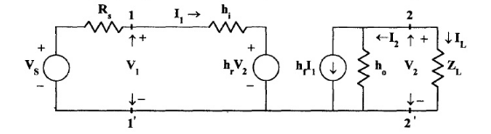
Fig. 1.5 Transistor replaced by its Hybrid Model
Current Gain or Current Amplification (A_{i})
For transistor amplifier the current gain A_{i} is defined as the ratio of output current to input current,i.e,
A_{i} =I_{L} /I₁ = -I₂ / I₁
From the circuit of Fig
I₂= h_{f} I₁ + h_{o}V₂
Substituting V₂ = I_{L}Z_{L} = -I₂Z_{L}
I₂= h_{f} I₁- I₂Z_{L} h_{o}
I₂ + I₂Z_{L} h_{o} = h_{f} I₁
I₂( 1+ Z_{L} h_{o}) = h_{f} I₁
A_{i} = -I₂ / I₁ = - h_{f} / ( 1+ Z_{L} h_{o})
Therefore,
A_{i} = - h_{f} / ( 1+ Z_{L} h_{o})
Input Impedence (Z_{i})
In the circuit of Fig , R_{S} is the signal source resistance .The impedence seen when looking into the amplifier terminals (1,1’) is the amplifier input impedence Z_{i},
Z_{i} = V₁ / I₁
From the input circuit of Fig V₁ = h_{i} I₁ + h_{r}V₂
Z_{i} = ( h_{i} I₁ + h_{r}V₂) / I₁
= h_{i} + h_{r} V₂ / I₁
Substituting
V₂ = -I₂ Z_{L} = A₁I₁Z_{L}
Z_{i} = h_{i} + h_{r} A₁I₁Z_{L} / I₁
= h_{i} + h_{r} A₁Z_{L}
Substituting for A_{i}
Z_{i} = h_{i} - h_{f} h_{r} Z_{L} / (1+ h_{o}Z_{L})
= h_{i} - h_{f} h_{r} Z_{L} / Z_{L}(1/Z_{L}+ h_{o})
Taking the Load admittance as Y_{L} =1/ Z_{L}
Z_{i} = h_{i} - h_{f} h_{r} / (Y_{L} + h_{o})
Voltage Gain or Voltage Gain Amplification Factor(A_{v})
The ratio of output voltage V₂ to input voltage V₁ give the voltage gain of the transistor i.e,
A_{v} = V₂ / V₁
Substituting
V₂ = -I₂ Z_{L} = A₁I₁Z_{L}
A_{v} = A₁I₁Z_{L} / V₁ = A_{i}Z_{L} / Z_{i}
Output Admittance (Y_{o})
Y_{o} is obtained by setting V_{S} to zero, Z_{L} to infinity and by driving the output terminals from a generator V_{2.} If the current V₂ is I₂ then Y_{o}= I₂/V₂ with V_{S}=0 and R_{L}= ∞.
From the circuit of fig
I₂= h_{f} I₁ + h_{o}V₂
Dividing by V_{2,}
I₂ / V₂ = h_{f} I₁/V₂ + h_{o}
With V₂= 0, by KVL in input circuit,
R_{S}I₁ + h_{i} I₁ + h_{r}V₂ = 0
(R_{S} + h_{i}) I₁ + h_{r}V₂ = 0
Hence, I₂ / V₂ = -h_{r} / (R_{S} + h_{i})
= h_{f} (-h_{r}/( R_{S} + h_{i})+h_{o}
Y_{o}= h_{o}- h_{f} h_{r}/( R_{S} + h_{i})
The output admittance is a function of source resistance. If the source impedence is resistive then Y_{o} is real.
Voltage Amplification Factor(A_{vs}) taking into account the resistance (R_{s}) of the source
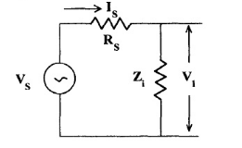
Fig. 5.6 Thevenin’s Equivalent Input Circuit
This overall voltage gain A_{vs} is given by
A_{vs} = V₂ / V_{S} = V₂V₁ / V₁V_{S} = A_{v} V₁/ V_{S}
From the equivalent input circuit using Thevenin’s equivalent for the source shown in Fig. 5.6
V₁ = V_{S} Z_{i} / (Z_{i +} R_{S})
V₁ / V_{S} = Z_{i} / ( Z_{i} + R_{S})
Then, A_{vs} = A_{v} Z_{i} / ( Z_{i} + R_{S})
Substituting A_{v} = A_{i}Z_{L} / Z_{i}
A_{vs} = A_{i}Z_{L} / ( Z_{i} + R_{S})
A_{vs} = A_{i}Z_{L} R_{S} / ( Z_{i} + R_{S}) R_{S}
A_{vs} = A_{is}Z_{L} / R_{S}

Current Amplification (A_{is}) taking into account the sourse Resistance(R_{S})
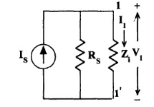
Fig. 1.7 Norton’s Equivalent Input Circuit
The modified input circuit using Norton’s equivalent circuit for the calculation of A_{is} is shown in Fig. 1.7
Overall Current Gain, A_{is} = -I₂ / I_{S} = - I₂I₁ /I₁ I_{S} = A_{i} I₁/I_{S}
From Fig. 1.7 I₁= I_{S} R_{S} / (R_{S} + Z_{i})
I₁ / I_{S} = R_{S} / (R_{S} + Z_{i})
and hence, A_{is} = A_{i} R_{S} / (R_{S} + Z_{i})

Operating Power Gain (A_{P})
The operating power gain A_{P} of the transistor is defined as
A_{P} = P₂ / P₁ = -V₂ I₂ / V₁ I₁ = A_{v}A_{i} = A_{i} A_{i}Z_{L}/ Z_{i}
A_{P} = A_{i}²(Z_{L}/ Z_{i})

Small Signal analysis of a transistor amplifier
A_{i} = - h_{f} / ( 1+ Z_{L} h_{o}) | A_{v} = A_{i}Z_{L} / Z_{i}
Z_{i} = h_{i} + h_{r} A₁Z_{L} = h_{i} - h_{f} h_{r} / (Y_{L} + h_{o}) | A_{vs} = A_{v} Z_{i} / ( Z_{i} + R_{S}) = A_{i}Z_{L} / ( Z_{i} + R_{S})  = A_{is}Z_{L} / R_{S}
Y_{o}= h_{o}- h_{f} h_{r}/( R_{S} + h_{i}) = 1/ Z_{o} | A_{is} = A_{i} R_{S} / (R_{S} + Z_{i}) = A_{vs} = A_{is} R_{S}/ Z_{L}

Simplified common emitter hybrid model:
In most practical cases it is appropriate to obtain approximate values of A _{V} , A _{i} etc rather than calculating exact values. How the circuit can be modified without greatly reducing the accuracy. Fig. 4 shows the CE amplifier equivalent circuit in terms of h-parameters Since 1 / h_{oe} in parallel with R_{L} is approximately equal to R_{L} if 1 / h_{oe} >> R_{L} then h_{oe} may be neglected. Under these conditions.
I_{c} = h_{fe} I_{B} .
h_{re} v_{c} = h_{re} I_{c} R_{L} = h_{re} h_{fe} I_{b} R_{L} .
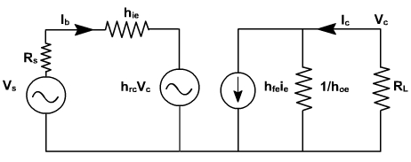
Fig. 4
Since h _{fe}.h _{re} = 0.01(approximately), this voltage may be neglected in comparison with h _{ic} I_{b} drop across h _{ie} provided R_{L} is not very large. If load resistance R_{L} is small than hoe and h_{re} can be neglected.
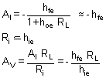
Output impedence seems to be infinite. When V_{s} = 0, and an external voltage is applied at the output we fined I_{b} = 0, I _{C} = 0. True value depends upon R_{S} and lies between 40 K and 80K.
On the same lines, the calculations for CC and CB can be done.
CE amplifier with an emitter resistor:
The voltage gain of a CE stage depends upon h_{fe}. This transistor parameter depends upon temperature, aging and the operating point. Moreover, h_{fe} may vary widely from device to device, even for same type of transistor. To stabilize voltage gain A _{V} of each stage, it should be independent of h_{fe}. A simple and effective way is to connect an emitter resistor R_{e} as shown in fig. 5. The resistor provides negative feedback and provide stabilization.
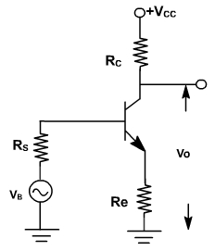
Fig. 5
An approximate analysis of the circuit can be made using the simplified model.
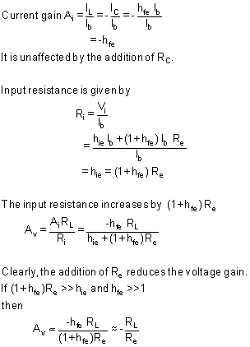
Subject to above approximation A _{V} is completely stable. The output resistance is infinite for the approximate model.

Comparison of Transistor Amplifier Configuration
The characteristics of three configurations are summarized in Table .Here the quantities A_{i},A_{v},R_{i},R_{o} and A_{P} are calculated for a typical transistor whose h-parameters are given in table .The values of R_{L} and R_{s} are taken as 3KΩ.
Table: Performance schedule of three transistor configurations
Quantity | CB | CC | CE
A_{I} | 0.98 | 47.5 | -46.5
A_{V} | 131 | 0.989 | -131
A_{P} | 128.38 | 46.98 | 6091.5
R_{i} | 22.6 Ω | 144 kΩ | 1065 Ω
R_{o} | 1.72 MΩ | 80.5 Ω | 45.5 kΩ

The values of current gain, voltage gain, input impedance and output impedance calculated as a function of load and source impedances
Characteristics of Common Base Amplifier
- Current gain is less than unity and its magnitude decreases with the increase of load resistance R_{L},
- Voltage gain A_{V} is high for normal values of R_{L},
- The input resistance R_{i} is the lowest of all the three configurations, and
- The output resistance R_{o} is the highest of all the three configurations.
Applications The CB amplifier is not commonly used for amplification purpose. It is used for
- Matching a very low impedance source
- As a non inverting amplifier to voltage gain exceeding unity.
- For driving a high impedance load.
- As a constant current source.

Characteristics of Common Collector Amplifier
- For low R_{L} (< 10 kΩ), the current gain A_{i} is high and almost equal to that of a CE amplifier.
- The voltage gain A_{V} is less than unity.
- The input resistance is the highest of all the three configurations.
- The output resistance is the lowest of all the three configurations.
Applications The CC amplifier is widely used as a buffer stage between a high impedance source and a low impedance load.
Characteristics of Common Emitter Amplifier
- The current gain A_{i} is high for R_{L} < 10 kΩ.
- The voltage gain is high for normal values of load resistance R_{L.}
- The input resistance R_{i} is medium.
- The output resistance R_{o} is moderately high.
Applications: CE amplifier is widely used for amplification.
Simplified common emitter hybrid model:
In most practical cases it is appropriate to obtain approximate values of A _{V} , A _{i} etc rather than calculating exact values. How the circuit can be modified without greatly reducing the accuracy. Fig 1. 8 shows the CE amplifier equivalent circuit in terms of h-parameters Since 1 / h_{oe} in parallel with R_{L} is approximately equal to R_{L} if 1 / h_{oe} >> R_{L} then h_{oe} may be neglected. Under these conditions.
I_{c} = h_{fe} I_{B} .
h_{re} v_{c} = h_{re} I_{c} R_{L} = h_{re} h_{fe} I_{b} R_{L} .
Fig 1.8
Since h _{fe}.h _{re} » 0.01, this voltage may be neglected in comparison with h _{ic} I_{b} drop across h _{ie} provided R_{L} is not very large. If load resistance R_{L} is small than hoe and h_{re} can be neglected.
Output impedence seems to be infinite. When V_{s} = 0, and an external voltage is applied at the output we fined I_{b} = 0, I _{C} = 0. True value depends upon R_{S} and lies between 40 K and 80K.
On the same lines, the calculations for CC and CB can be done.
CE amplifier with an emitter resistor:
The voltage gain of a CE stage depends upon h_{fe}. This transistor parameter depends upon temperature, aging and the operating point. Moreover, h_{fe} may vary widely from device to device, even for same type of transistor. To stabilize voltage gain A _{V} of each stage, it should be independent of h_{fe}. A simple and effective way is to connect an emitter resistor R_{e} as shown in fig.1.9. The resistor provides negative feedback and provide stabilization.
Fig.1.9
An approximate analysis of the circuit can be made using the simplified model.
Subject to above approximation A _{V} is completely stable. The output resistance is infinite for the approximate model.
Common Base Amplifier:
The common base amplifier circuit is shown in Fig. 1. The V_{EE} source forward biases the emitter diode and V_{CC} source reverse biased collector diode. The ac source v_{in} is connected to emitter through a coupling capacitor so that it blocks dc. This ac voltage produces small fluctuation in currents and voltages. The load resistance R_{L} is also connected to collector through coupling capacitor so the fluctuation in collector base voltage will be observed across R_{L}.  The dc equivalent circuit is obtained by reducing all ac sources to zero and opening all capacitors. The dc collector current is same as I_{E} and V_{CB} is given by  V_{CB} = V_{CC} - I_{C} R_{C}. | 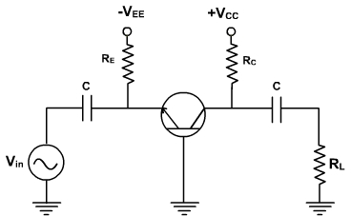  Fig. 1
These current and voltage fix the Q point. The ac equivalent circuit is obtained by reducing all dc sources to zero and shorting all coupling capacitors. r'_{e} represents the ac resistance of the diode as shown in Fig. 2.
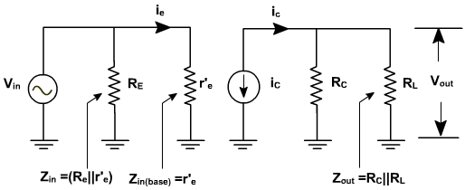
Fig. 2
Fig. 3, shows the diode curve relating I_{E} and V_{BE}. In the absence of ac signal, the transistor operates at Q point (point of intersection of load line and input characteristic). When the ac signal is applied, the emitter current and voltage also change. If the signal is small, the operating point swings sinusoidally about Q point (A to B).
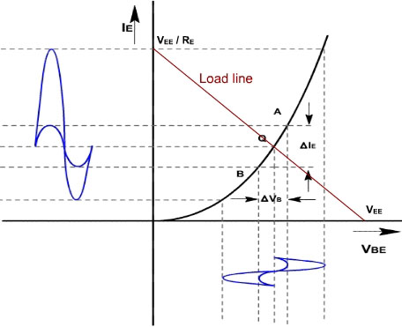
Fig .3
If the ac signal is small, the points A and B are close to Q, and arc A B can be approximated by a straight line and diode appears to be a resistance given by
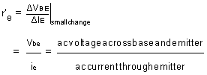
If the input signal is small, input voltage and current will be sinusoidal but if the input voltage is large then current will no longer be sinusoidal because of the non linearity of diode curve. The emitter current is elongated on the positive half cycle and compressed on negative half cycle. Therefore the output will also be distorted.
r'_{e} is the ratio of ΔV_{BE} and Δ I_{E} and its value depends upon the location of Q. Higher up the Q point small will be the value of r' e because the same change in V_{BE} produces large change in I_{E}. The slope of the curve at Q determines the value of r'_{e}. From calculation it can be proved that.
r'_{e} = 25mV / I_{E}

Common Base Amplifier
Proof:
In general, the current through a diode is given by
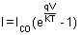
Where q is he charge on electron, V is the drop across diode, T is the temperature and K is a constant.
On differentiating w.r.t V, we get,
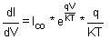
The value of (q / KT) at 25°C is approximately 40.
Therefore, 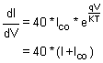
or, 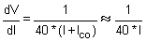

To a close approximation the small changes in collector current equal the small changes in emitter current. In the ac equivalent circuit, the current ‘i_{C}' is shown upward because if ‘i_{e}' increases, then ‘i_{C}' also increases in the same direction.
Voltage gain:
Since the ac input voltage source is connected across r'_{e}. Therefore, the ac emitter current is given by
i_{e} = V_{in} / r'_{e}
or, V_{in} = ie r'_{e}
The output voltage is given by V_{out} = i_{c} (R_{C} || R_{L})
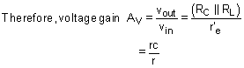
Under open circuit condition v_{out} = i_{c} R_{c}
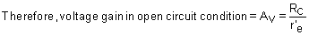

Example-1
Find the voltage gain and output of the amplifier shown in fig. 4, if input voltage is 1.5mV.
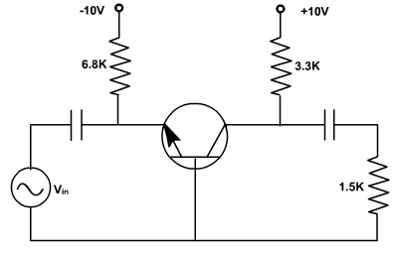
Fig. 4
Solution:
The emitter dc current I E is given by 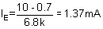
Therefore, emitter ac resistance = 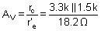
or, A_{V}= 56.6
and, V_{out} = 1.5 x 56.6 = 84.9 mV

Example-2
Repeat example-1 if ac source has resistance R s = 100 W .
Solution:
The ac equivalent circuit with ac source resistance is shown in fig. 5.
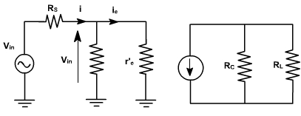
Fig. 5
The emitter ac current is given by 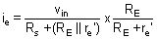
or, 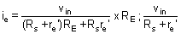
Therefore, voltage gain of the amplifier = 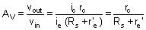
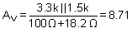
and, V_{out} = 1.5 x 8.71 =13.1 mV
Small Signal CE Amplifiers:
CE amplifiers are very popular to amplify the small signal ac. After a transistor has been biased with a Q point near the middle of a dc load line, ac source can be coupled to the base. This produces fluctuations in the base current and hence in the collector current of the same shape and frequency. The output will be enlarged sine wave of same frequency.
The amplifier is called linear if it does not change the wave shape of the signal. As long as the input signal is small, the transistor will use only a small part of the load line and the operation will be linear.
On the other hand, if the input signal is too large. The fluctuations along the load line will drive the transistor into either saturation or cut off. This clips the peaks of the input and the amplifier is no longer linear.
The CE amplifier configuration is shown in fig. 1.
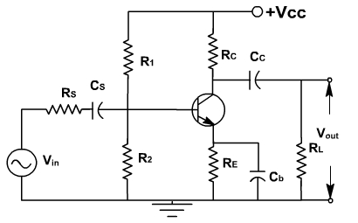
Fig. 1
The coupling capacitor (C_{C} ) passes an ac signal from one point to another. At the same time it does not allow the dc to pass through it. Hence it is also called blocking capacitor.
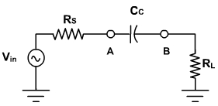
Fig. 2
For example in fig. 2, the ac voltage at point A is transmitted to point B. For this series reactance X_{C} should be very small compared to series resistance R_{S}. The circuit to the left of A may be a source and a series resistor or may be the Thevenin equivalent of a complex circuit. Similarly R_{L} may be the load resistance or equivalent resistance of a complex network. The current in the loop is given by
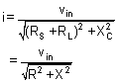
As frequency increases,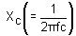decreases, and current increases until it reaches to its maximum value v_{in} / R. Therefore the capacitor couples the signal properly from A to B when X_{C}<< R. The size of the coupling capacitor depends upon the lowest frequency to be coupled. Normally, for lowest frequency X_{C}  0.1R is taken as design rule.
The coupling capacitor acts like a switch, which is open to dc and shorted for ac.
The bypass capacitor C_{b} is similar to a coupling capacitor, except that it couples an ungrounded point to a grounded point. The C_{b} capacitor looks like a short to an ac signal and therefore emitter is said ac grounded. A bypass capacitor does not disturb the dc voltage at emitter because it looks open to dc current. As a design rule X_{Cb}  0.1R_{E} at Analysis of CE amplifier:
In a transistor amplifier, the dc source sets up quiescent current and voltages. The ac source then produces fluctuations in these current and voltages. The simplest way to analyze this circuit is to split the analysis in two parts: dc analysis and ac analysis. One can use superposition theorem for analysis .
AC & DC Equivalent Circuits:
For dc equivalent circuit, reduce all ac voltage sources to zero and open all ac current sources and open all capacitors. With this reduced circuit shown in fig. 3 dc current and voltages can be calculated.
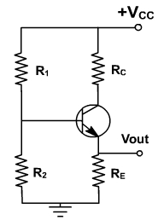
Fig. 3
For ac equivalent circuits reduce dc voltage sources to zero and open current sources and short all capacitors. This circuit is used to calculate ac currents and voltage as shown in fig. 4.
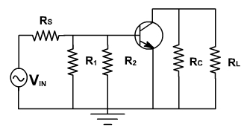
Fig. 4
The total current in any branch is the sum of dc and ac currents through that branch. The total voltage across any branch is the sum of the dc voltage and ac voltage across that branch.
Phase Inversion:
Because of the fluctuation is base current; collector current and collector voltage also swings above and below the quiescent voltage. The ac output voltage is inverted with respect to the ac input voltage, meaning it is 180º out of phase with input.
During the positive half cycle base current increase, causing the collector current to increase. This produces a large voltage drop across the collector resistor; therefore, the voltage output decreases and negative half cycle of output voltage is obtained. Conversely, on the negative half cycle of input voltage less collector current flows and the voltage drop across the collector resistor decreases, and hence collector voltage increases we get the positive half cycle of output voltage as shown in fig. 5.
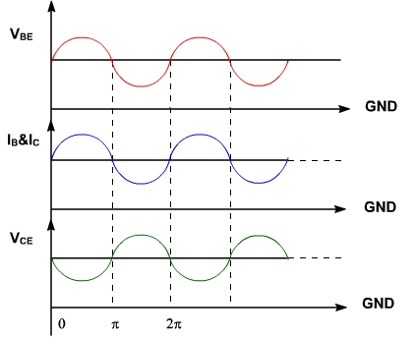
Fig. 5
lowest frequency.

AC Load line:
Consider the dc equivalent circuit fig. 1.
Fig. 1
Assuming I_{C} = I_{C}(approx), the output circuit voltage equation can be written as
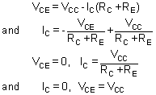
The slop of the d.c load line is 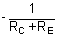.
When considering the ac equivalent circuit, the output impedance becomes R_{C} || R_{L} which is less than (R_{C} +R_{E}).
In the absence of ac signal, this load line passes through Q point. Therefore ac load line is a line of slope (-1 / ( R_{C} || R_{L}) ) passing through Q point. Therefore, the output voltage fluctuations will now be corresponding to ac load line as shown in fig. 2. Under this condition, Q-point is not in the middle of load line, therefore Q-point is selected slightly upward, means slightly shifted to saturation side.
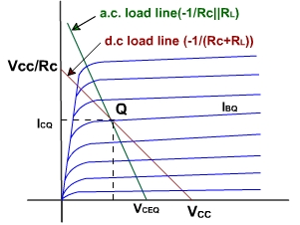
Fig. 2
Analysis of CE amplifier
Voltage gain:
To find the voltage gain, consider an unloaded CE amplifier. The ac equivalent circuit is shown in fig. 3. The transistor can be replaced by its collector equivalent model i.e. a current source and emitter diode which offers ac resistance r'_{e}.
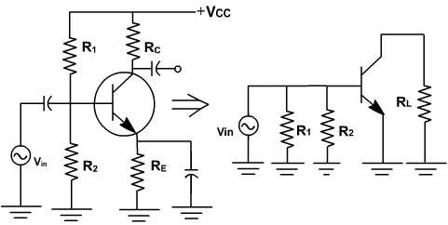
Fig. 3
The input voltage appears directly across the emitter diode.
Therefore emitter current i_{e} = V_{in} / r'_{e}.
Since, collector current approximately equals emitter current and i_{C} = i_{e} and v_{out} = - i_{e} R_{C} (The minus sign is used here to indicate phase inversion)
Further v_{out} = - (V_{in} R_{C}) / r'_{e}
Therefore voltage gain A = v_{out} / v_{in} = -R_{C} / r'_{e}
The ac source driving an amplifier has to supply alternating current to the amplifier. The input impedance of an amplifier determines how much current the amplifier takes from the ac source.
In a normal frequency range of an amplifier, where all capacitors look like ac shorts and other reactance are negligible, the ac input impedance is defined as
z_{in}= v_{in}/ i_{in}
Where v_{in}, i_{in} are peak to peak values or rms values
The impedance looking directly into the base is symbolized z_{in (base)} and is given by
Z _{in(base)} = v_{in} / i_{b} ,
Since,v _{in} = i_{e} r'_{e}
z_{in (base)} = r'_{e}.
From the ac equivalent circuit, the input impedance z_{in} is the parallel combination of R₁ , R₂ and r'_{e}.
Z_{in} = R₁ || R₂ ||  r'_{e}
The Thevenin voltage appearing at the output is
v_{out} = A v_{in}
The Thevenin impedance is the parallel combination of R_{C} and the internal impedance of the current source. The collector current source is an ideal source, therefore it has an infinite internal impedance.
z_{out} = R_{C}.
The simplified ac equivalent circuit is shown in fig. 4.
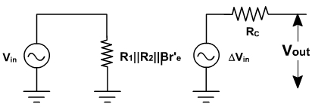
Analysis of CE amplifier
Example-1:
Select R1 and R2 for maximum output voltage swing in the circuit shown in fig. 5.
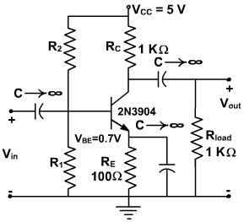
Fig. 5
Solution:
We first determine ICQ for the circuit
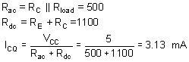
For maximum swing,
V'CC = 2 VCEQ
The quiescent value for VCE is the given by
VCEQ= (3.13 mA) (500 W ) = 1.56 V
The intersection of the ac load line on the vCE axis is V'CC = 3.13V. From the manufacturer's specification, β for the 2N3904 is 180. RB is set equal to 0.1 βRE. So,
RB = 0.1(180 )(100) = 1.8 K W
VBB = (3.13 x 10-3) (1.1 x 100) + 0.7 = 1.044 V
Since we know VBB and RB, we find R1 and R2,
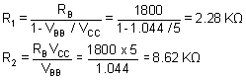
The maximum output voltage swing, ignoring the non-linearity's at saturation and cutoff, would then be
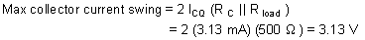
The load lines are shown on the characteristics of fig. 6.
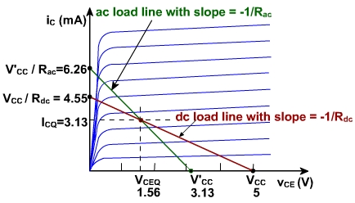
Fig. 6
The maximum power dissipated by the transistor is calculated to assure that it does not exceed the specifications. The maximum average power dissipated in the transistor is
P(transistor)= VCEQ ICQ = (1.56 (V)) (3.13 mA) =4.87 mW
This is well within the 350 mW maximum given on the specification sheet. The maximum conversion efficiency is
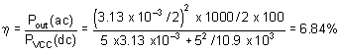
The swamped Amplifier:
The ac resistance of the emitter diode r'e equals 25mV / IE and depends on the temperature. Any change in r'e will change the voltage gain in CE amplifier. In some applications, a change in voltage is acceptable. But in many applications we need a stable voltage gain is required.
To make it stable, a resistance rE is inserted in series with the emitter and therefore emitter is no longer ac grounded. fig .7.
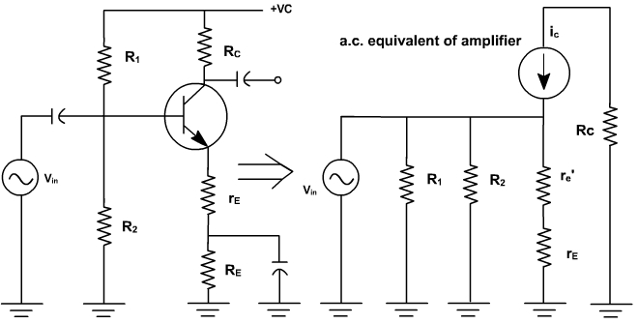
Fig. 7
Because of this the ac emitter current flows through rE and produces an ac voltage at the emitter. If rE is much greater than r'e almost all of the ac input signal appears at the emitter, and the emitter is bootstrapped to the base for ac as well as for dc.
In this case, the collector circuit is given by
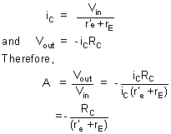
Now r'e has a less effect on voltage gain, swamping means rE >> r'e If swamping is less, voltage gain varies with temperature. If swamping is heavy, then gain reduces very much.
Design of Amplifier :

Example -1 (Common Emitter Amplifier Design)
Design a common-emitter amplifier with a transistor having a β =200 and VBE = 0.7 V. Obtain an overall gain of |A V | ≥ 100 and maximum output voltage swing. Use the CE configuration shown in fig. 1 with two power supplies. Rsource is the resistance associated with the source, vsource. Let Rsource= 100 Ohms. The output load is 2KΩ. Determine the resistor values of the bias circuitry, the maximum undistorted output voltage swing, and the stage voltage gain.
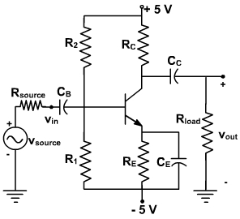
Fig. 1
Solution:
The maximum voltage across the amplifier is 10 V since the power supply can be visualized as a 10V power supply with a ground in the center. In this case, the ground has no significance to the operation of the amplifier since the input and output are isolated from the power supplies by capacitors.
We will have to select the value for RC and we are really not given enough information to do so. Let choose RC = Rload.
We don't have enough information to solve for RB – we can't use the bias stability criterion since we don't have the value of RE either. We will have to (arbitrarily) select a value of RB or RE. If this leads to a contradiction, or “bad” component values (e.g., unobtainable resistor values), we can come back and modify our choice. Let us select a value for RE that is large enough to obtain a reasonable value of VBB, Selecting RE as 400Ω will not appreciably reduce the collector current yet it will help in maintaining a reasonable value of VBB. Thus,
RB = 0.1 β RE = 0.1 (200)(400) = 8 K Ω
To insure that we have the maximum voltage swing at the output, we will use
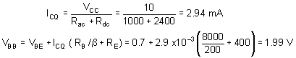
Note that we are carrying out our calculations to four places so that we can get accuracy to three places. The bias resistors are determined by
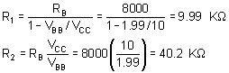
Since we designed the bias circuit to place the quiescent point in the middle of the ac load line, we can use
Vout(undistorted p-p) 1.8 (2.94 x 10-3 ) (2 K Ω || 2 K Ω ) =5.29 V
Now we can determine the gain of the amplifier itself.
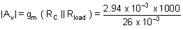
Using voltage division, we can determine the gain of the overall circuit.
The value of Rin can be obtained as
Thus the overall gain of the amplifier is
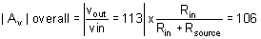
This shows that the common-emitter amplifier provides high voltage gain. However, it is very noisy, it has a low input impedance, and it does not have the stability of the emitter resistor common emitter a
Design of Amplifier
Example-2 (Emitter-Resistor Amplifier Design)
Design an emitter-resistor amplifier as shown in fig. 2 to drive a 2 KΩ load using a pnp silicon transistor, V_{CC} = -24V, β = 200, A_{v} = -10, and V_{BE} = -0.7 V. Determine all element values and calculate A_{i}, R_{in}, I_{CQ} and the maximum undistorted symmetrical output voltage swing for three values of R_{C} as given below:
- R_{C} = R_{load}
- R_{C} = 0.1 R_{load}
- R_{C} = 10 R_{load}
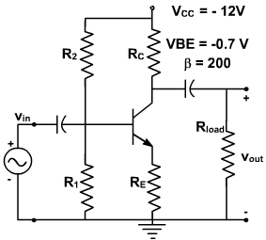
Fig. 2
Solution:
(a) R_{C} = R_{load}
We use the various equations derived in previous lecture in order to derive the parameters of the circuit.
From the voltage gain, we can solve for R'_{E}.
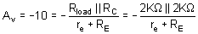
So R'_{E} = r_{e} + R_{E} = 100 Ω
We can find the quiescent value of the collector current I_{C} form the collector-emitter loop using the equation for the condition of maximum output swing.
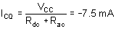
Therefore, 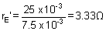
This is small enough that we shall ignore it to find that R_{E} = 100 Ω. Since we now know β and R_{E}. We can use the design guideline.
R_{B} = 0.1 β R_{E} = 2 k Ω
As designed earlier, the biasing circuitry can be designed in the same manner and given by
V_{BB} = -1.52 V
R₁ = 2.14 K Ω
R₂ = 3.6 K Ω
The maximum undistorted symmetrical peak to peak output swing is then
V_{out} (P-P) = 1.8 I_{CQ} (R_{load} || R_{C} ) = 13.5 V
Thus current gain A_{i} = -9.1
and input impedance R_{in} = 1.82 K Ω
(b) R_{C} = 0.1 R_{load}
we repeat the steps of parts (a) to find
R_{C} =200 Ω | R_{i} = 390 Ω
I_{CQ} =-57.4 mA | R₂ =4.7K Ω
r'_{e} = 0.45 Ω | v_{out}(p-p) = 18.7 V
R_{B} = 360 Ω | A_{i} = -1.64
V_{BB} = -1.84 V | R_{in} = 327 Ω
(C) R_{C} =10 R_{load}
Once again, we follow the steps of part (a) to find
R_{C} =20 K Ω | R₁ =3.28K Ω
I_{CQ} =-1.07 mA | R₂ = 85.6K Ω
r'_{e} = 24.2 Ω | v_{out}(p-p) = 3.9 V
R_{B} = 3.64K Ω | A_{i} =-14.5
V_{BB} = -0.886 V | R_{in} = 2.91K W
We now compare the results obtained Table-I for the purpose of making the best choice for R_{C}.
 | I_{CQ} | A_{i} | R_{in} | v_{out}(p-p)
R_{C} = R_{load} | -7.5 mA | -9.1 | 1.82K W | 13.5 V
R_{C} = 0.1 R_{load} | -57.4 mA | -1.64 | 327 W | 20.8 V
R_{C} = 10 R_{load} | -1.07mA | -14.5 | 2.91W | 3.9 V
Table - 1 Comparsion for the three selections of R_{C}
It indicates that of the three given ratios of R_{C} to R_{load}, R_{C} = R_{load} has the most desirable performance in the CE amplifier stage.
It can be used as a guide to develop a reasonable designs. In most cases, this choice will provide performance that meets specifications. In some applications, it may be necessary to do additional analysis to find the optimum ratio of R_{C} to R_{load}.
mplifier.
Design of Amplifier
Example-2 (Emitter-Resistor Amplifier Design)
Design an emitter-resistor amplifier as shown in fig. 2 to drive a 2 KΩ load using a pnp silicon transistor, V_{CC} = -24V, β = 200, A_{v} = -10, and V_{BE} = -0.7 V. Determine all element values and calculate A_{i}, R_{in}, I_{CQ} and the maximum undistorted symmetrical output voltage swing for three values of R_{C} as given below:
- R_{C} = R_{load}
- R_{C} = 0.1 R_{load}
- R_{C} = 10 R_{load}
Fig. 2
Solution:
(a) R_{C} = R_{load}
We use the various equations derived in previous lecture in order to derive the parameters of the circuit.
From the voltage gain, we can solve for R'_{E}.
So R'_{E} = r_{e} + R_{E} = 100 Ω
We can find the quiescent value of the collector current I_{C} form the collector-emitter loop using the equation for the condition of maximum output swing.
Therefore,
This is small enough that we shall ignore it to find that R_{E} = 100 Ω. Since we now know β and R_{E}. We can use the design guideline.
R_{B} = 0.1 β R_{E} = 2 k Ω
As designed earlier, the biasing circuitry can be designed in the same manner and given by
V_{BB} = -1.52 V
R₁ = 2.14 K Ω
R₂ = 3.6 K Ω
The maximum undistorted symmetrical peak to peak output swing is then
V_{out} (P-P) = 1.8 I_{CQ} (R_{load} || R_{C} ) = 13.5 V
Thus current gain A_{i} = -9.1
and input impedance R_{in} = 1.82 K Ω
(b) R_{C} = 0.1 R_{load}
we repeat the steps of parts (a) to find
R_{C} =200 Ω | R_{i} = 390 Ω
I_{CQ} =-57.4 mA | R₂ =4.7K Ω
r'_{e} = 0.45 Ω | v_{out}(p-p) = 18.7 V
R_{B} = 360 Ω | A_{i} = -1.64
V_{BB} = -1.84 V | R_{in} = 327 Ω

(C) R_{C} =10 R_{load}
Once again, we follow the steps of part (a) to find
R_{C} =20 K Ω | R₁ =3.28K Ω
I_{CQ} =-1.07 mA | R₂ = 85.6K Ω
r'_{e} = 24.2 Ω | v_{out}(p-p) = 3.9 V
R_{B} = 3.64K Ω | A_{i} =-14.5
V_{BB} = -0.886 V | R_{in} = 2.91K W
We now compare the results obtained Table-I for the purpose of making the best choice for R_{C}.
 | I_{CQ} | A_{i} | R_{in} | v_{out}(p-p)
R_{C} = R_{load} | -7.5 mA | -9.1 | 1.82K W | 13.5 V
R_{C} = 0.1 R_{load} | -57.4 mA | -1.64 | 327 W | 20.8 V
R_{C} = 10 R_{load} | -1.07mA | -14.5 | 2.91W | 3.9 V
Table - 1 Comparsion for the three selections of R_{C}
It indicates that of the three given ratios of R_{C} to R_{load}, R_{C} = R_{load} has the most desirable performance in the CE amplifier stage.
It can be used as a guide to develop a reasonable designs. In most cases, this choice will provide performance that meets specifications. In some applications, it may be necessary to do additional analysis to find the optimum ratio of R_{C} to R_{load}.
Design of Amplifier
Example- 3 (Capacitor-Coupled Emitter-Resistor Amplifier Design)
Design an emitter-resistor amplifier as shown in fig. 3 with A_{V} =-10, β =200 and R load = 1K Ω. A pnp transistor is used and maximum symmetrical output swing is required.
Fig. 3
Solution:
As designed earlier, we shall chose R_{C} = R_{load} = 10 kΩ.
The voltage gain is given by 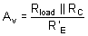
where R'_{E}= R_{E} + r'_{e}.
Substituting A_{V}, R_{load} and R_{C} in this equation, we find R'_{E}= 50 Ω.
We need to know the value of r'_{e} to fine R_{E}. We first find R_{ac} and R_{dc}, and then calculate the Q point as follows (we assume r'_{e} is small, so R_{E} = R'_{E})
R_{ac} = R_{E} + R_{C} || R_{load} = 550 Ω
R_{dc} = R_{E} + R_{C} = 1050 Ω
Now, the first step is to calculate the quiescent collector current needed to place the Q-point into the center of the ac load line (i.e., maximum swing). The equation is
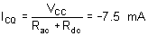
The quantity, r'_{e} , is found as follows
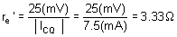
Then
R_{E} = 50 - r_{e} = 46.67 Ω
If there were a current gain or input resistance specification for this design, we would use it to solve for the value of R_{B}. Since is no such specification, we use the expression
R_{B} =0.1 β R_{E} = 0.1 (200) (46.6) = 932 Ω
Then continuing with the design steps,
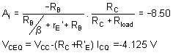
and
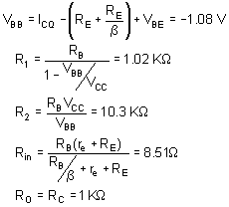
The last equality assumes that r_{O} is large compared to R_{C}.
The maximum undistorted peak to peak output swing is given by
1.8 | I_{CQ} | ( R_{C} || R_{load} )=1.8 ( 0.0075 ) ( 500 ) = 6.75 V
The power delivered into the load and the maximum power dissipated by the transistor are found as
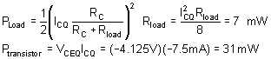
The load lines for this circuit are shown in fig. 4.
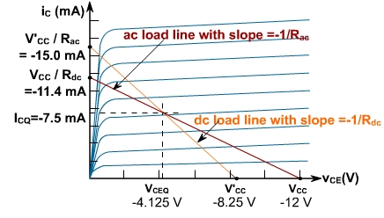
Common Collector Amplifier:
If a high impedance source is connected to low impedance amplifier then most of the signal is dropped across the internal impedance of the source. To avoid this problem common collector amplifier is used in between source and CE amplifier. It increases the input impedence of the CE amplifier without significant change in input voltage.
Fig. 1, shows a common collector (CC) amplifier. Since there is no resistance in collector circuit, therefore collector is ac grounded. It is also called grounded collector amplifier. When input source drives the base, output appears across emitter resistor. A CC amplifier is like a heavily swamped CE amplifier with a collector resistor shorted and output taken across emitter resistor.
v_{out} = v_{in} - v_{BE}
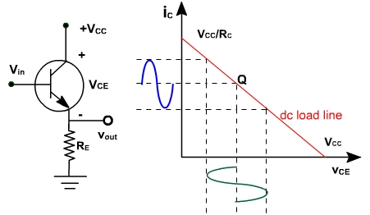
Fig. 1
Therefore, this circuit is also called emitter follower, because V_{BE} is very small. As v_{in} increases, v_{out} increases.
If v_{in} is 2V, v_{out} = 1.3V
If v_{in} is 3V, v_{out} = 2.3V.
Since v_{out} follows exactly the v_{in} therefore, there is no phase inversion between input and output.
The output circuit voltage equation is given by
V_{CE} = V_{CC} – I_{E} R_{E}
Since I_{E} = I_{C}
I_{C} = (V_{CC} – V_{CE} ) / R_{E}
This is the equation of dc load line. The dc load line is shown in Fig. 1.

Common Collector Amplifier:
Voltage gain:
Fig. 2, shows an emitter follower driven by a small ac voltage. The input is applied at the base of transistor and output is taken across the emitter resistor. Fig. 3, shows the ac equivalent circuit of the amplifier. The emitter is replaced by ac resistance r'_{e}.
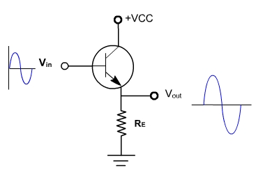 | 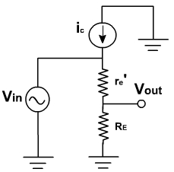
Fig. 2 | Fig. 3

The ac output voltage is given by  v_{out} = R_{E} i_{e}  and, v_{in} = i_{e} (R_{E} + r'_{e} )  Therefore, A = R_{E} / ( R_{E} +r'_{e} )  Since r'_{e} << R_{E}   Av= 1. (approx)  Therefore, it is a unity gain amplifier. The practical emitter follower circuit is shown in Fig. 4. | 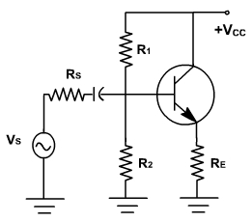  Fig. 4
The ac source (v_{S}) with a series resistance R_{S} drives the transistor base. Because of the biasing resistor and input impedance of the base, some of the ac signal is lost across the source resistor. The ac equivalent circuit is shown in Fig. 5.
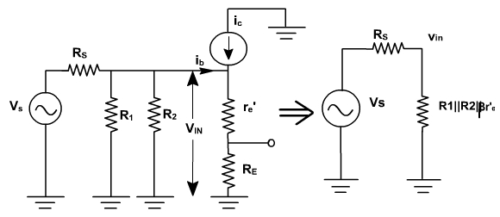
Fig. 5
The input impedance at the base is given by
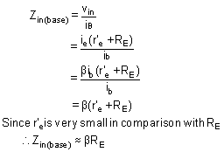
The total input impedance of an emitter follower includes biasing resistors in parallel with input impedance of the base.
z_{in} = R₁ || R₂|| (r'_{e} + R_{E})
Since R_{E} is very large as compared to R₁ and R₂.
Thus, z_{in} ≈ R₁ || R₂
Therefore input impedance is very high.
Applying Thevenin's theorem to the base circuit of Fig. 5, it becomes a source v_{in} and a series resistance (R₁ || R₂ || R_{S} ) as shown in Fig. 6.
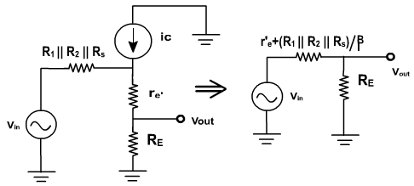
Fig. 6
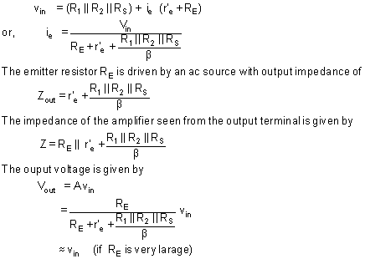

Common Collector Amplifier
Example 1:
Find the Q-point of the emitter follower circuit of fig. 7 with R₁ = 10 KΩ and R₂ = 20 KΩ. Assume the transistor has a β of 100 and input capacitor C is very-very large.
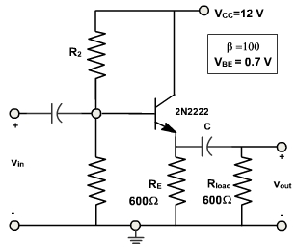
Fig. 7
Solution:
We first find the Thevenin's equivalent of the base bias circuitry.
R_{B} = R₁ || R₂ = 6.67 K Ω
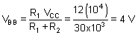
From the bias equation we have
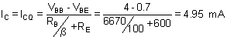
Example - 2
Find the output voltage swing of the circuit of fig. 7.
Solution:
The Q-Point location has already been calculated in Example-1. We found that the quiescent collector current is 4.95 mA.
The Output voltage swing = 2 . I_{C} peak . (R_{E} || R_{Load}) = 2(4.95 x 10⁻³) (300) = 2.97V
This is less than the maximum possible output swing. Continuing the analysis,
V_{CEQ} = V_{CC} – I_{CQ} R_{E} = 9.03 V
V'_{CC} = V_{CEQ} + I_{CQ} (R_{E} || R_{Load} ) = 10.5 V
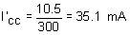
The load lines for this problem are shown in Fig. 8.
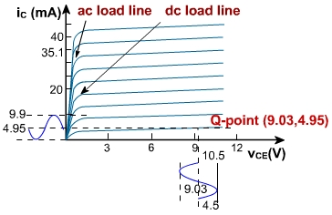
CLASSIFICATION OF AMPLIFIERS:
A circuit that increases the amplitude of the given input signal is an amplifier.A small ac signal fed to the amplifier is obtained as a larger ac signal of the same frequency at the output.Amplifiers constitute an essential part of radio,television and other communication circuits.Depending on the nature and level of amplification and the impedance matching requirements different types of amplifiers can be considered and they are discussed in this chapter.
Amplifiers can be classified as follows:
1.Based on the transistor configuration
(a) Common emitter amplifier
(b) Common base amplifier
(c ) Common emitter amplifier

2.Based on the active devices
(a) BJT amplifier
(b) FET amplifier
3.Based on the Q-point(operating condition)
(a) Class A amplifier
(b) Class B amplifier
(c) Class C amplifier
(d) Class AB amplifier
4.Based on the number of stages
(a) Single stage amplifiers
(b) Multistage amplifiers
5.Based on the output
(a)Voltage amplifiers
(b)Power amplifiers
6.Based on the frequency response
(a)Audio frequency(AF) amplifier
(b)Intermediate Frequency amplifier(IF)
(c )Radio Frequency amplifier(RF)
7.Based on the bandwidth
(a)Narrow band amplifier(normally RF amplifier)
(b)Wide band amplifier(normally video amplifier)
Distortion in amplifiers:

Amplifier Distortion
From the previous tutorials we learnt that for a signal amplifier to work correctly it requires some form of DC Bias on its Base or Gate terminal so that it amplifies the input signal over its entire cycle with the bias "Q-point" set as near to the middle of the load line as possible. This then gave us a "Class-A" type amplification with the most common configuration being Common Emitter for Bipolar transistors and Common Source for unipolar transistors. We also saw that the Power, Voltage or Current Gain, (amplification) provided by the amplifier is the ratio of the peak input value to its peak output value. However, if we incorrectly design our amplifier circuit and set the biasing Q-point at the wrong position on the load line or apply too large an input signal, the resultant output signal may not be an exact reproduction of the original input signal waveform. In other words the amplifier will suffer from distortion. Consider the common emitter amplifier circuit below.

Common Emitter Amplifier
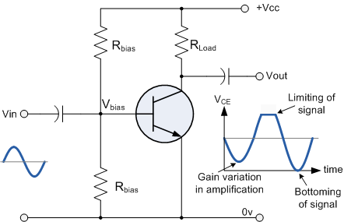
Distortion of the signal waveform may take place because:
1. Amplification may not be taking place over the whole signal cycle due to incorrect biasing.
2. The input signal may be too large, causing the amplifier to limit.
3. The amplification may not be linear over the entire frequency range of inputs.
This means then that during the amplification process of the signal waveform, some form of Amplifier Distortion has occurred.
Amplifiers are basically designed to amplify small voltage input signals into much larger output signals and this means that the output signal is constantly changing by some factor or value times the input signal for all input frequencies. We saw previously that this multiplication factor is called the Beta, β value of the transistor. Common emitter or even common source type transistor circuits work fine for small AC input signals but suffer from one major disadvantage, the bias Q-point of a bipolar amplifier depends on the same Beta value which may vary from transistors of the same type, ie. the Q-point for one transistor is not necessarily the same as the Q-point for another transistor of the same type due to the inherent manufacturing tolerances. If this occurs the amplifier may not be linear and Amplitude Distortion will result but careful choice of the transistor and biasing components can minimise the effect of amplifier distortion.

Amplitude Distortion
Amplitude distortion occurs when the peak values of the frequency waveform are attenuated causing distortion due to a shift in the Q-point and amplification may not take place over the whole signal cycle. This non-linearity of the output waveform is shown below.

Amplitude Distortion due to Incorrect Biasing
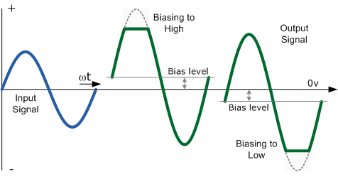
If the bias is correct the output waveform should look like that of the input waveform only bigger, (amplified). If there is insufficient bias the output waveform will look like the one on the right with the negative part of the output waveform "cut-off". If there is too much bias the output waveform will look like the one on the left with the positive part "cut-off". When the bias voltage is too small, during the negative part of the cycle the transistor does not conduct fully so the output is set by the supply voltage. When the bias is too great the positive part of the cycle saturates the transistor and the output drops almost to zero.
Even with the correct biasing voltage level set, it is still possible for the output waveform to become distorted due to a large input signal being amplified by the circuits gain. The output voltage signal becomes clipped in both the positive and negative parts of the waveform an no longer resembles a sine wave, even when the bias is correct. This type of amplitude distortion is called Clipping and is the result of "Over-driving" the input of the amplifier.
When the input amplitude becomes too large, the clipping becomes substantial and forces the output waveform signal to exceed the power supply voltage rails with the peak (+ve half) and the trough (-ve half) parts of the waveform signal becoming flattened or "Clipped-off". To avoid this the maximum value of the input signal must be limited to a level that will prevent this clipping effect as shown above.

Amplitude Distortion due to Clipping
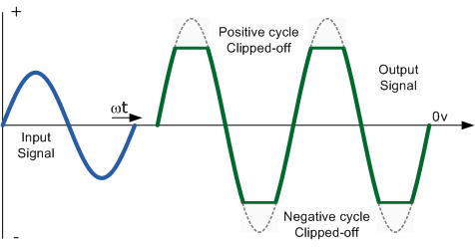
Amplitude Distortion greatly reduces the efficiency of an amplifier circuit. These "flat tops" of the distorted output waveform either due to incorrect biasing or over driving the input do not contribute anything to the strength of the output signal at the desired frequency. Having said all that, some well known guitarist and rock bands actually prefer that their distinctive sound is highly distorted or "overdriven" by heavily clipping the output waveform to both the +ve and -ve power supply rails. Also, excessive amounts of clipping can also produce an output which resembles a "square wave" shape which can then be used in electronic or digital circuits.
We have seen that with a DC signal the level of gain of the amplifier can vary with signal amplitude, but as well as Amplitude Distortion, other types of distortion can occur with AC signals in amplifier circuits, such as Frequency Distortion and Phase Distortion.

Frequency Distortion
Frequency Distortion occurs in a transistor amplifier when the level of amplification varies with frequency. Many of the input signals that a practical amplifier will amplify consist of the required signal waveform called the "Fundamental Frequency" plus a number of different frequencies called "Harmonics" superimposed onto it. Normally, the amplitude of these harmonics are a fraction of the fundamental amplitude and therefore have very little or no effect on the output waveform. However, the output waveform can become distorted if these harmonic frequencies increase in amplitude with regards to the fundamental frequency. For example, consider the waveform below:

Frequency Distortion due to Harmonics

In the example above, the input waveform consists a the fundamental frequency plus a second harmonic signal. The resultant output waveform is shown on the right hand side. The frequency distortion occurs when the fundamental frequency combines with the second harmonic to distort the output signal. Harmonics are therefore multiples of the fundamental frequency and in our simple example a second harmonic was used. Therefore, the frequency of the harmonic is 2 times the fundamental, 2 x f or 2f. Then a third harmonic would be 3f, a fourth, 4f, and so on. Frequency distortion due to harmonics is always a possibility in amplifier circuits containing reactive elements such as capacitance or inductance.

Phase Distortion
Phase Distortion or Delay Distortion occurs in a non-linear transistor amplifier when there is a time delay between the input signal and its appearance at the output. If we call the phase change between the input and the output zero at the fundamental frequency, the resultant phase angle delay will be the difference between the harmonic and the fundamental. This time delay will depend on the construction of the amplifier and will increase progressively with frequency within the bandwidth of the amplifier. For example, consider the waveform below:

Phase Distortion due to Delay

Any practical amplifier will have a combination of both "Frequency" and "Phase" distortion together with amplitude distortion but in most applications such as in audio amplifiers or power amplifiers, unless the distortion is excessive or severe it will not generally affect the operation of the system.

